New Member Pack

updated September 2017

www.nckc.co.uk

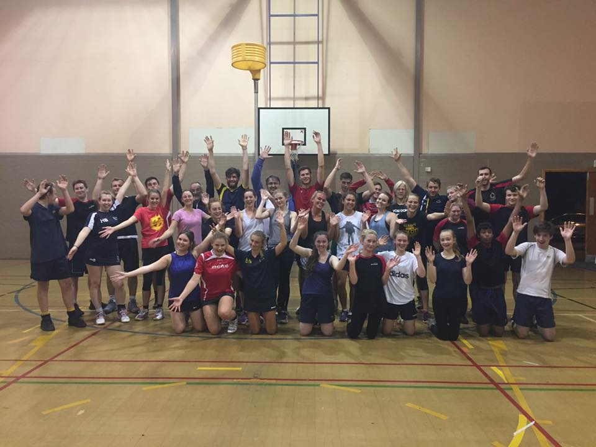
Key contacts:
Philip Buttinger 01603 219002 M. 07794 844497
Marion Catlin 01603 765353 M. 07946 261651

Dear new member

Welcome to Norwich City Korfball Club. We hope that you will enjoy playing with us.

The club was founded in 1994 and has been central to the development of korfball in Norfolk ever since. The club is family-friendly and has a really good track-record for developing young and new players. We pride ourselves in welcoming everybody and making them feel part of the club from the beginning. We never turn people away and are particularly good at developing confidence in those who are not sure that they like team sport. If you just want to turn up to training and play casually that is fine but we also welcome ambitious players who want to develop their sport. We foster talent and will help people with ambition to play for England if that is what they want to do. Either way, we will help to advise and train you to play to your ability and availability.

If you do have children or family, you are welcome to bring them to matches as there is almost always one or two willing helpers on the sidelines. We would rather help you overcome any barriers to playing so please let us know if you are having a practical problem such as transport or childcare.

If you would like to join one of our league teams (we have six), playing on Sunday afternoon/evenings. We start people playing in a team as soon as they are happy to do so and the coaches and players offer support. Generally, coaches will contact players in the week before a match but fixtures are available in advance and it is safe to assume that you if you are in a team, there will be a game most Sundays late afternoon/evening.

Training
Club training is held at City of Norwich School on Tuesday evenings 6pm-9.30pm every week during term-time unless cancelled through hall availability. Sign up for Twitter and follow @nckc or members’ Facebook https://www.facebook.com/groups/2400682913/
Junior training for
- Years 2-6 is 6pm–7pm
- Years 7-9 is 7-8pm
- And seniors (year 10 and up) is 8-9.30pm

We often go for a social drink after training. Korfball is good for your social life too!

Subscriptions
As a member, you are required to pay a monthly subscription of £15 for waged members and £10 for unwaged members by standing order.

The extra sum of £5 for waged members is treated as a donation which allows the Club to reclaim tax on the amount. This subscription covers your training and match fees throughout the year, and a club shirt. Tournament and travel costs are not covered.

Please can you complete the form below and send the standing order to your bank as soon as possible.

Other club information
The club strip is red and white shirt (mostly red) and either plain black or black/red shorts or skirt.

League matches are played on Sundays from late September to Easter or just after. The league matches are indoors and generally played at the UEA Sportspark.

League details and fixtures can be found at the Norfolk Korfball Association website
www.norfolkkorfball.co.uk.

There are opportunities to play in outdoor tournaments through the summer months when the league stops. These are organised by individual clubs and it is up to members to arrange entry.

Norwich City also has a website www.nckc.co.uk as well as a Facebook group and Twitter account @NorwichCitykorfbal. There is a committee to run the club which meets when necessary, with an AGM late summer.

Norwich City currently has four teams. NC1 and 2 in Division 1, NC3, NC4 and NC5 in Division 2 and NC 6 in Division 3 of the Norfolk League. We also have a South East Regional League (SERL) team which has specific selection sessions - see Coach Rob Bloomer for details of SERL

Club members are allocated to a team at the beginning of the season and places are reviewed at Christmas when there is a short break. The team lists are then submitted to the league secretary. We hope that players will come to training regularly to improve their play as a team member as well as an individual, and to increase their understanding of the game, although we do understand that some people cannot come regularly. Please talk to your coach if this is the case.

Each team has a coach who is responsible each week for making sure we field ‘legal’ teams with the correct players. It is really helpful if members can look at the fixtures and keep the days free when their allocated team is playing. Matches are usually confirmed in the week before the game by email or text, again it is helpful if players can check their emails/texts and respond quickly.

Please keep a note of your coach’s telephone number in case of emergency.

Players under the age of 18 wishing to play in the local league have to fill in a signed consent form to the NKA Executive. Players without a form will not be allowed to play!
More information can be found at www.nckc.co.uk but please don’t hesitate to ask a senior player if there is anything that you would like to know.

Finally, a very warm welcome to the Club.

Key people
Philip Buttinger, chair and 3rd team coach and junior coach
Rob Bloomer 1st team coach and committee member
Joe Skeet 2nd team coach, referee coordinator and committee member
Lizzie Reeve, 4th team coach and committee member
Marion Catlin, 5th/6th team coach and committee member 07946 261651
Nicola Crow Child Protection Officer
Claire Green, Social Secretary
Gerald Brown,Treasurer
Fiona Brown, Secretary

Please fill in the form below so that we have your contact details for communication and safety. Boxes with an asterisk * are necessary, others optional

First Name* |  | Surname* |  |  | DoB*
Address*
 |  |  | Postcode*
Telephone number*
Email address*
Mobile phone number*
Occupation
Medical information eg allergies, conditions, illnesses or injuries*

Do you consider yourself to have a disability or other consideration?
Emergency name and number*
Previous korfball experience?
Would you be prepared to
Referee? |  | Coach a team?
Play? |  | Run training sessions?
Help out? |  | Join the committee?
Do you have any family that play?

I confirm that the above details are correct and may be stored on computer databases for the use of administering of korfball.

Signature:

Other permissions

I give permission for photographs of myself being displayed on the Club’s website and other promotional and general publicity material.

Signature:

I give permission for my child to take part in korfball training and games, including league matches.(Players under 18 need their form signed by a parent) *

Signature:

Please fill in the standing order form below and send to your bank or if you prefer, set up a standing order online.

To: The Manager of
Type to enter text
Please transfer £ monthly on the 1st of each month, starting

to Norwich City Korfball Club's account at Charities Aid Foundation Bank

Account Number: 00014148 Sort Code: 40-52-40

My account name is :
Type to enter text

Account Number:

Sort Code:

Signature:

